Association of Army Dentistry
(AAD)


Support

Promote

Association of Army Dentistry (AAD)

Recognize

BOARD OF DIRECTORS:

Ronald J. Lambert
COL, USA (Ret.)
President and Chairman

Priscilla H. Hamilton
COL, USA (Ret.)

Larry J. Hanson
COL, USA (Ret)

V. Sterlene Hapner
US Army Civilian

Edward M. Knights
COL, USA (Ret)

James C. Kulild
COL, USA (Ret)

Andrew W. Lehmkuhl
Principal, Edge Advisors

Nasrin Mazuji
COL, USA (Ret)

Michael J. McQuade
COL, USA (Ret.)

Michael P. Rethman
COL, USA (Ret.)

Richard D. Shipley
COL, USA (Ret.)

Ronald D. Silverman
MG, USA (Ret.)

Peter M. Tan
COL, USA (Ret)

M. Ted Wong
MG, USA (Ret.)

Newsletter Winter 2018

With the recent celebration of Thanksgiving and the holiday season here, it is time to be thankful for our blessings. As I reflect back on my military career, I am thankful for the opportunities presented to me, friends I made, role models and mentors who shaped my career, and the memories of the places that I served. As I reminisce about the Army days with friends, we realize we stayed for the people and a cause greater than ourselves, serving our country. We traveled extensively, worked with great people, and took care of the greatest patients in the world, America's Soldiers.

On behalf of the Board of Directors of the Association of Army Dentistry, we wish each of our members and their families, a joyous and happy holiday season, and good health, happiness, and adventures in the year ahead! Please keep our brave young men and women serving around the world protecting our freedoms in your thoughts and prayers during the holidays and throughout the year.

Ron
Ronald J. Lambert, COL, USA (Ret)
President and Chairman, Board of Directors

Interment of MG Bill B. Lefler

The interment ceremony for MG Bill B. Lefler, the 20th Chief of the U.S. Army Dental Corps, took place on 1 October 2018 at Arlington National Cemetery in Arlington, Virginia. MG Lefler served as Chief of the Corps from 1986-1990. The Lefler family reserved a block of rooms at The Virginian Suites in Arlington, where family and friends participated in a "Celebration of Life" for MG Lefler after the ceremony. Photos of the ceremony at Arlington were provided by the Lefler family.

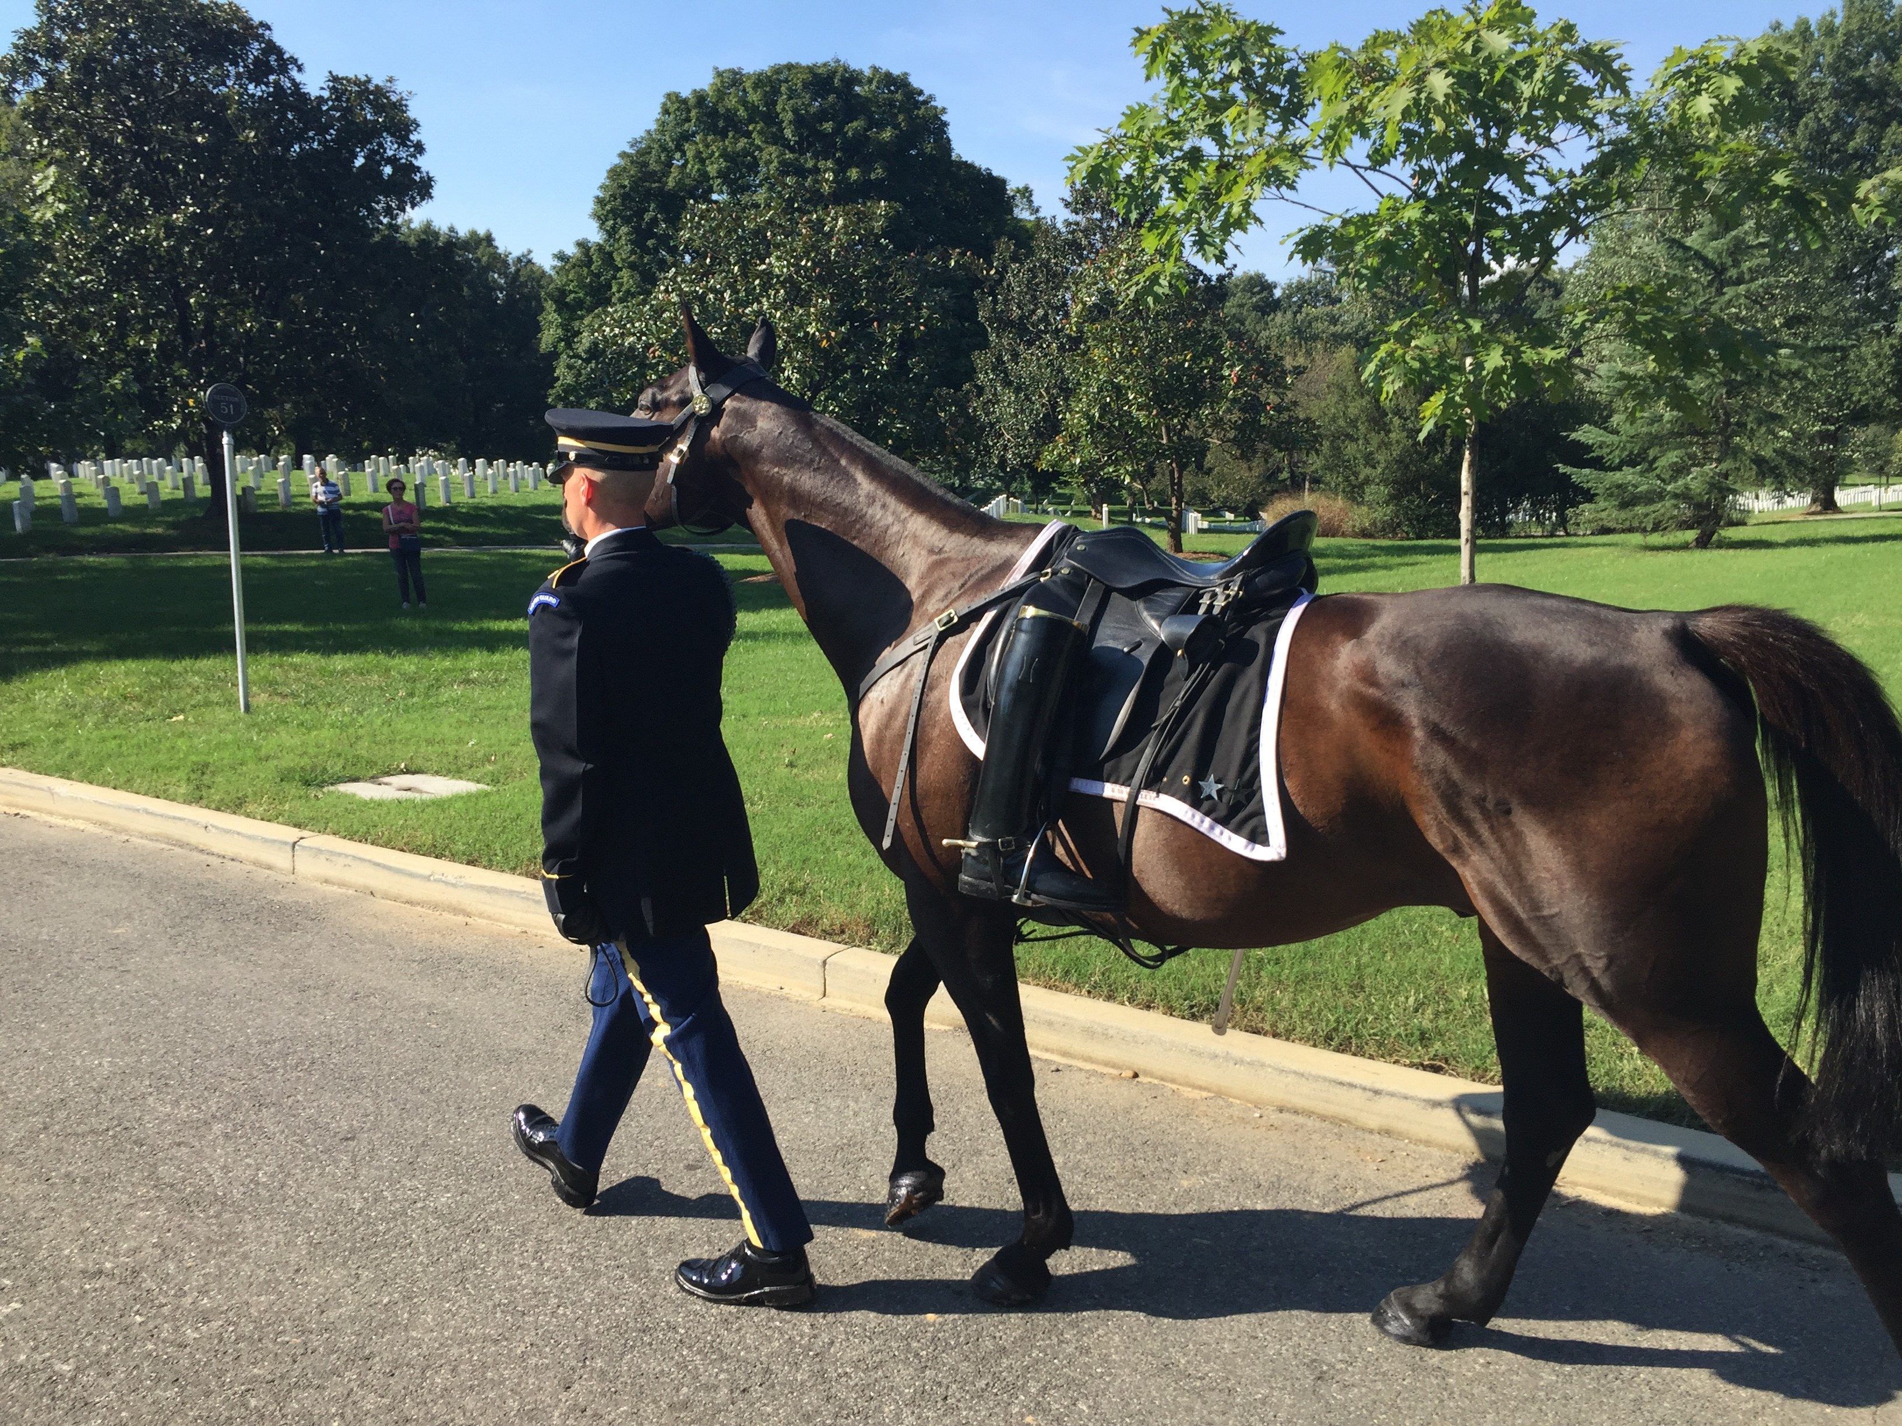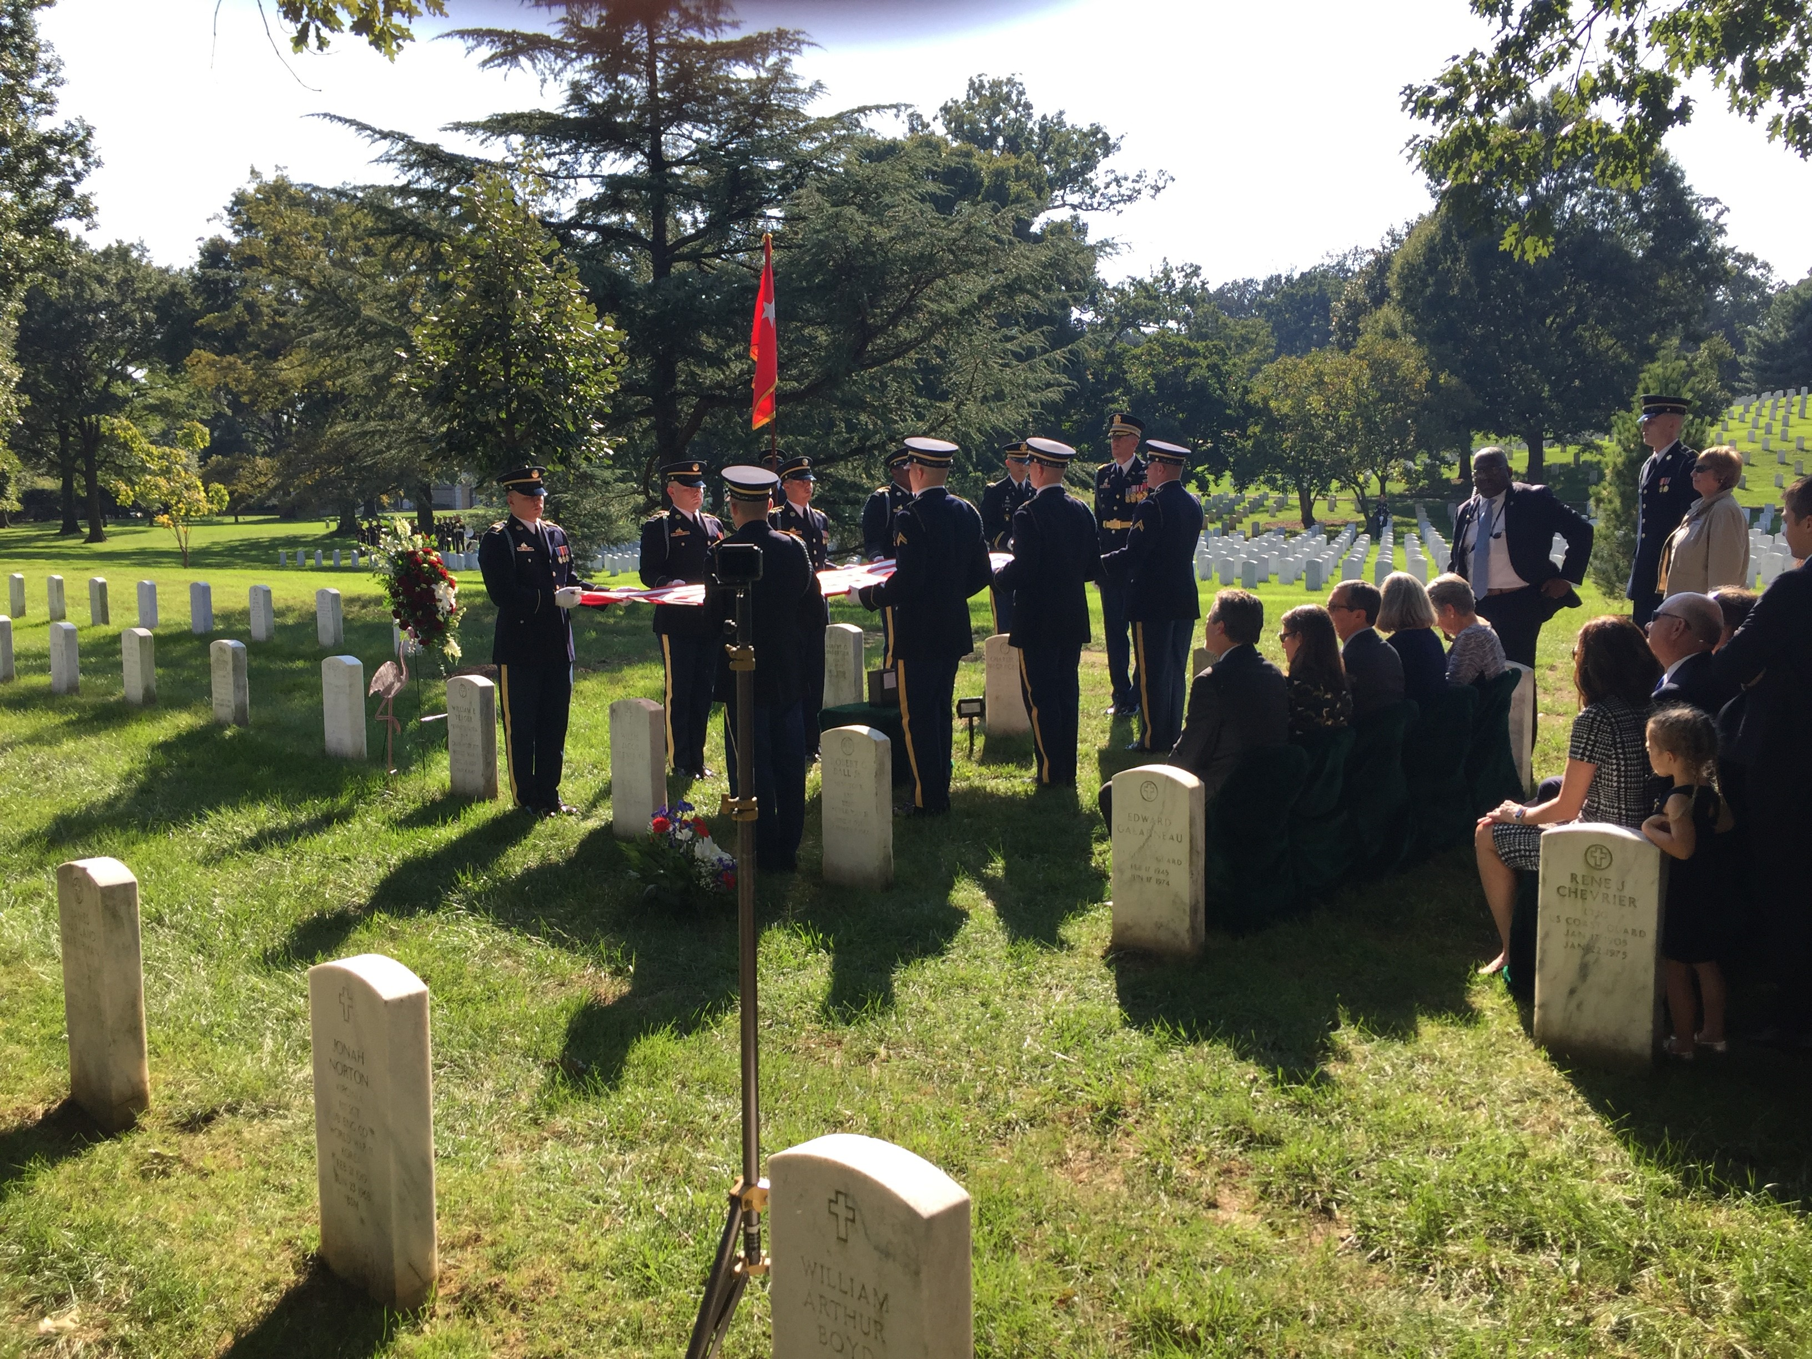
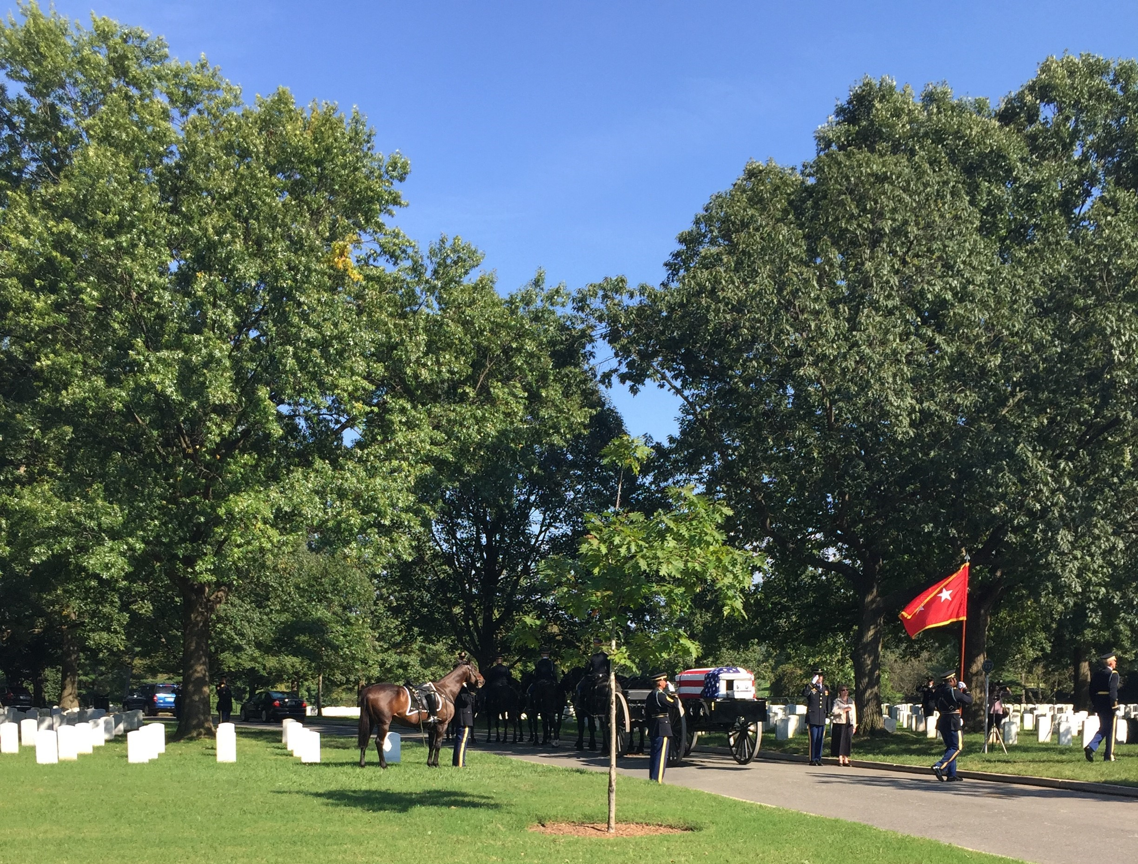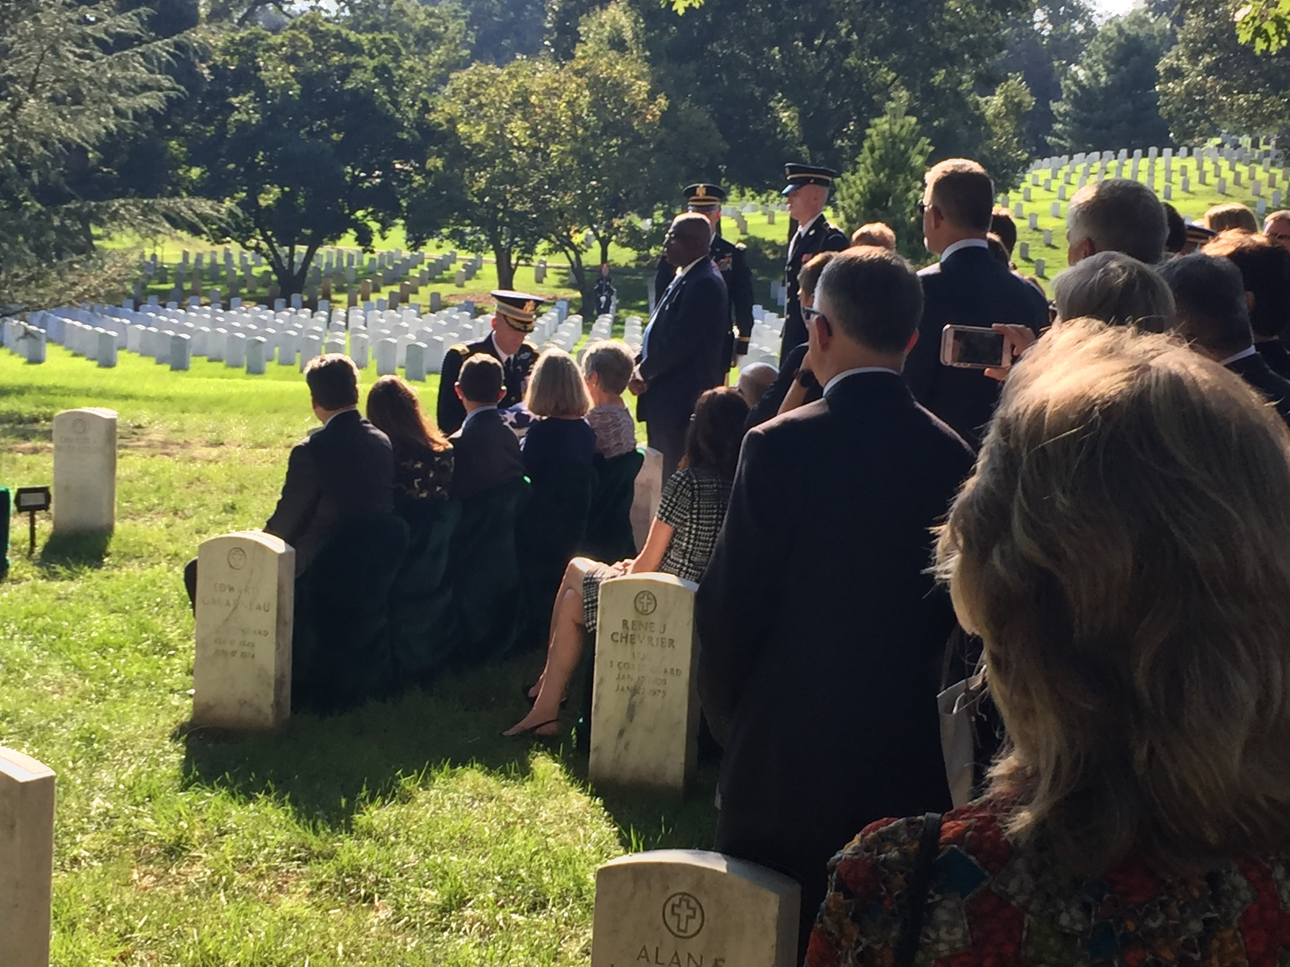

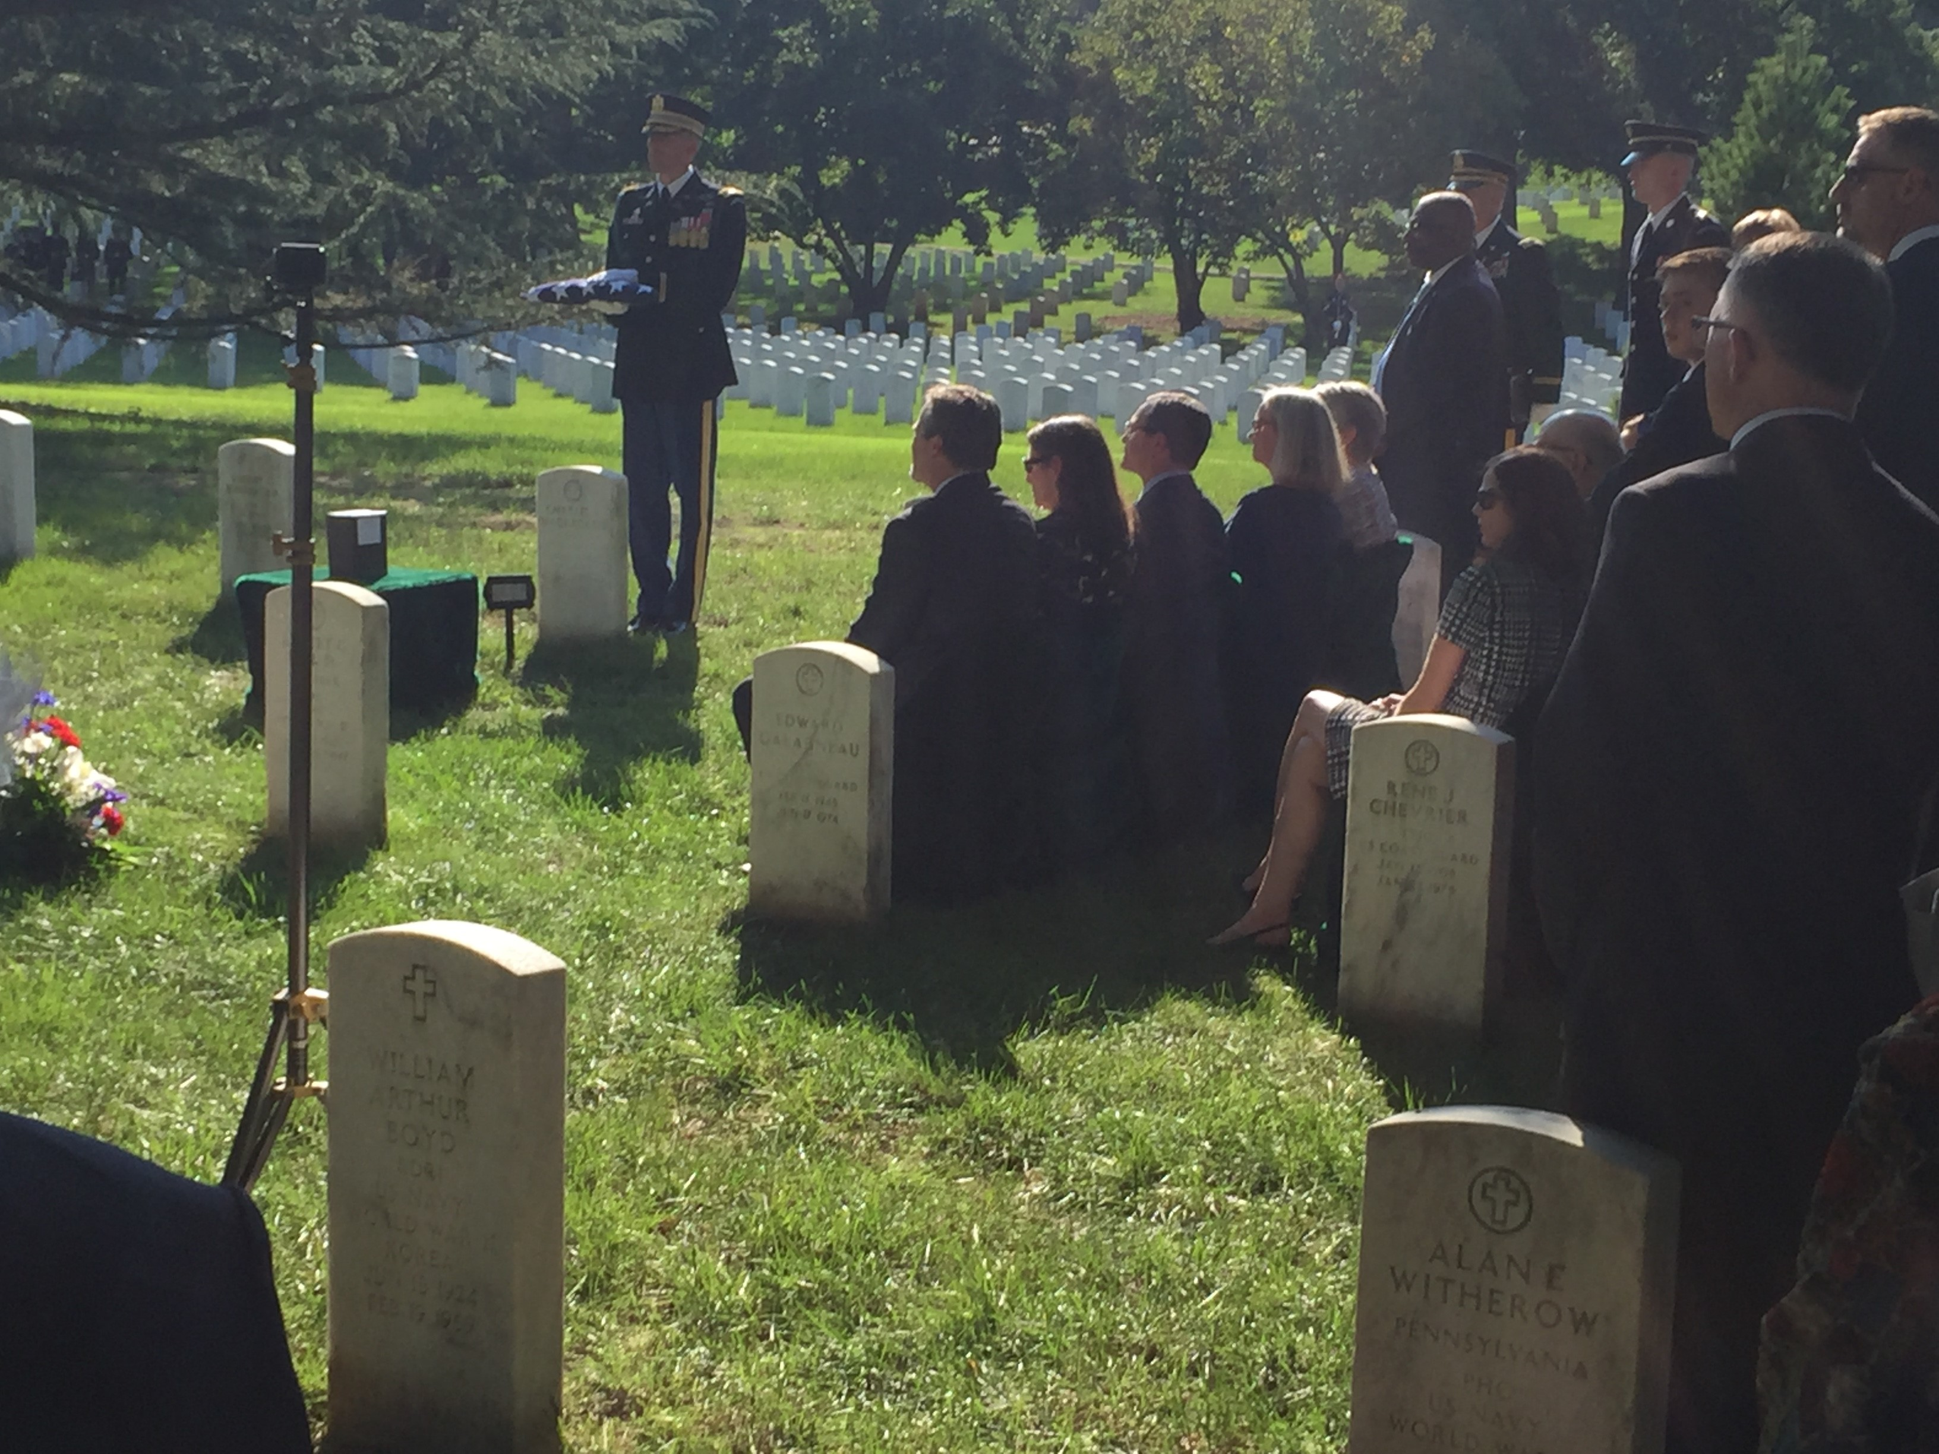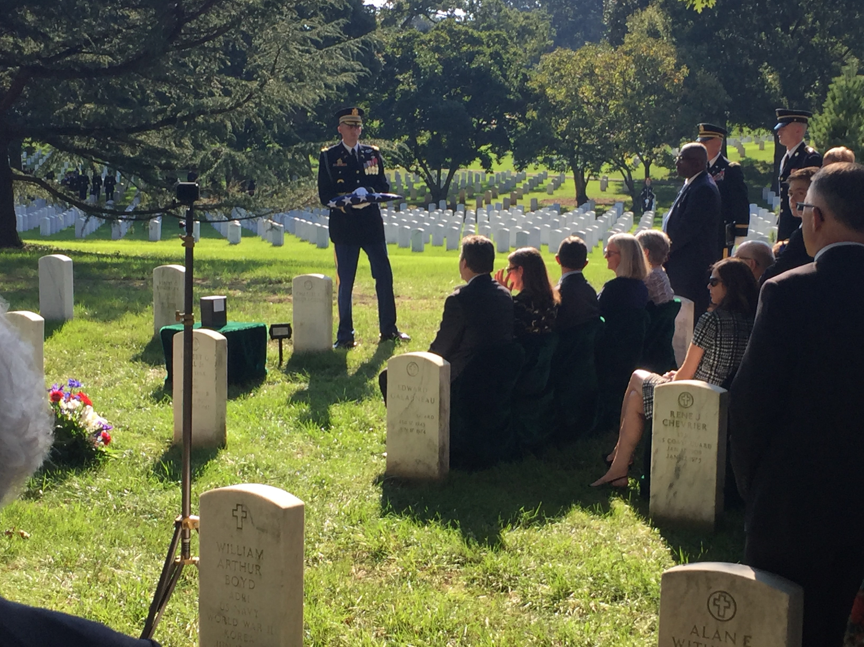

Attached is a photo of past Dental Corps Chiefs and their better halves who attended the ceremony. The photo was taken after the memorial dinner for General Lefler at the Kona Grill in Arlington. Pictured are MG Jim and Bonnie Cuddy, MG Joe and COL Ann Webb, MG Russ and Michelle Czerw, MG Ted and Jeannie Wong, BG Jerry and Patsy Strader.


Membership

The Association of Army Dentistry (AAD) has been working with Brown Boots Interactive, the administrator for the AAD's website, to update our website. As part of the system update, establishing and renewing memberships through our website has been facilitated. The membership renewal process will move to a fluid membership year, not one based on the calendar year. That is, if you renew in January, your membership year will run one calendar year from the date of renewal. The membership year for current members expires on 31 December. Each year you will be notified via e-mail prior to the expiration of your membership. Follow the link to go to the AAD website at www.associationofarmydentistry.org to renew your membership, either electronically or by downloading the membership form and mailing it in. The Board of Directors at its November meeting approved a new Life Membership category in addition to the Student Membership and Professional Membership categories.

Thank you for renewing your membership and for your donations in support of our 501(c)(3) mission, including recognition of deceased members by providing a memorial at the U.S. Army Medical Department (AMEDD) Museum, recognition of Captain's Career Course Honor graduates, receptions at the Officer Basic Course welcoming new Dental Corps Officers each summer, support for Dental Corps Birthday Balls, mentorship, and continuing education endeavors.

Active Component News

The 108th Dental Corps Birthday Ball, sponsored by the Dental Health Command - Atlantic, will be held on Saturday, the sixteenth day of March, 2019, at the Crystal Gateway Marriott Hotel, Arlington Ballroom, 1700 Jefferson Davis Highway, Arlington, Virginia 22202. The social hour commences at six o'clock in the evening, with the receiving line by BG Shan Bagby, Chief of the U.S. Army Dental Corps, at six thirty, followed by dinner at seven o'clock.
CPT Paul J. Gilroy, serves as the Executive Fellow at Office of the Chief, US Army Dental Corps, Joint Base San Antonio, Fort Sam Houston, Texas. He functions as the primary liaison with the Association of Army Dentistry under the direction of COL Craig Patterson, the Corps Specific Branch Proponent Officer at the Corps Chief's office. CPT Gilroy provided the July, August, and September editions of The Dental Corps Bulletin, which can be found on our webpage at the link below.
https://www.associationofarmydentistry.org/the-dental-corps-bulletin-2/

Go for the Greens
In a long-anticipated move, the Army officially adopted the "Army Greens" as its everyday business wear uniform, returning the Army Blues to use as a formal dress uniform. Army leadership had advocated for adoption of the iconic World War II uniform worn by America's "Greatest Generation" in the belief that it will inspire soldiers, enhance esprit de corps and play an important role in attracting quality people into the Army.
What to watch: The Army Greens will be fielded to soldiers reporting to their first units as early as the summer of 2020. The mandatory wear date for all so will be in 2028.

Reserve Components News

This month's article features COL Mark Stanalajczo, who currently serves as the Individual Mobilization Augmentee (IMA) Commander, Dental Health Command - Pacific. COL Stanalajczo lives in Whitmore Lake, Michigan with his wife, Christy, and their two children, Jack and Lena. He has been in private practice for 29+ years as a solo practitioner. Mark was sworn in as a Captain in the US Army Reserves in January 1999. He will be starting as an Adjunct Clinical Assistant Professor in January 2019 at his alma mater, the University of Michigan School of Dentistry. COL Stanalajczo will complete 20 years of military service on January 7, 2019.

To read Col Stanalajczo's story, please click on the attachment.

An American Dream – COL Stanalajczo

American Dental Association (ADA)

The October 15, 2018 edition of the ADA News announced the test of an online platform matching dentists during key transitions. The program will be piloted in Maine and Wisconsin. The purpose of the pilot initiative is to help foster relationships between dentists and practice owners at key transition points in their careers. The link to the site for the Wisconsin Dental Association (WDA) is as follows:

https://www.ada.org/jobs

The pilot program was developed after field research uncovered a need in the marketplace for dentists who want to connect for both employment opportunities and to facilitate the transition of a practice from one owner to another. Research also found additional needs for learning skills related to basic business management, ownership, patient acquisition, purchasing, and staff relationships. Once a match is made, an ADA advisor will be assigned to the partnership to help facilitate the process and foster a positive relationship for both parties, beyond acquisition and into the transition.
Piloting the program in Maine and Wisconsin will allow testing the service appropriately and improvements to make for the next step in scaling the service to a national level.
COL (Ret) Dick Shipley and his mentorship committee are working on the AAD's guide to opportunities after the service. The ADA's pilot programs fit well into his committee's vision.

Healthcare Corner
This edition of the newsletter features an article by MG (Ret) M. Ted Wong, DDS, MHA, Chief Dental Officer, UnitedHealthCare at UnitedHealth Group in southern California. General Wong served as the 26th Chief of the Army Dental Corps from 2010 - 2014. He examines the effects of the 2018 election on the health care marketplace.

Post-2018 Election Healthcare Outlook

With a divided government (Republicans controlling the executive branch and Senate, and Democrats controlling the House) and polarized partisan priorities, it will be difficult to pass sweeping health care legislation. At best, there could be minor enhancements/modifications to existing policies, laws, and funding in the health care arena, even though Health Care is considered a key issue by most Americans. Exit polls from the mid-elections indicated that 41% of Americans felt Health Care was the most important issue followed by immigration and the economy. A majority of voters favored the Affordable Care Act (51%) and a single payer Medicare system (42%), while 69% felt the health care system needed major changes. Although the turnout for the mid-term elections by Republicans and Democrats did not significantly change from previous years, the significant shift of independents, young voters, and women from conservative to liberal ideology influenced the election outcomes for the House of Representative races.

Observations

The US health care system is strongly influenced by local factors, with significant variation from one area to another and between plans. There is much debate over who should be the owner of health benefits coverage, the Federal government, State government, or individuals. Meaningful health care reform should seek to expand access to affordable and universal health care benefits, preserve choice and stability of plans, avoid disruption to the current system, and promote innovation.
Greater than ninety percent of Americans have access to health care benefits through Employer-Sponsored Insurance, Medicare, Medicaid, and Health Insurance Exchanges, leaving over 25 million people without insurance. The lack of affordable health care for millions of Americans results in gaps in care, fragmented care, and undesirable health care behaviors. US health care costs continue to rise, with costs estimated to be over $3.7 trillion in 2018. Health care expenses for families have doubled over the last ten years, per capita spending exceeds $11,000, and unnecessary health care taxes and fees add another $16 billion in costs. In spite of being one of the world's richest economies and spending nearly twenty percent of its GDP on health care, the US lags behind in many quality of care measures and outcomes, efficient use of health care resources, and patient experience.

Recommendations from a Major Health Care Insurer

Expand access to care: Preserve employer-sponsored insurance through appropriate tax, give the States oversight of Individual Markets, allow insurers the flexibility to offer broader selection of innovative and customized health benefits products, expand Medicaid and allow more flexible managed care plans, expand Medicare Advantage, and provide more cost management oversight for pharmaceuticals.

Reduce Health Care Costs: Expand primary care models and innovative payment models, leverage pharmacy management tools, expand use of value-based care and reimbursement programs, develop and implement intelligent data management and analytic tools that support improved health care decisions and outcomes, revise the pharmaceutical industry through value-based pricing and pharmacy benefits managers, and repeal the Health Insurance Tax and State Health Care Taxes.

Improve Quality Health Care: Use real-time health data, intelligence, and technology to drive evidence-based decisions by providers and patients, implement a provider-designation program based on quality and value, expand use of, and access to digital health records, transform the Fee-For-Service payment system to a Values-Based Reimbursement system, expand care coordination within the industry, and allow safe and increased use of new technologies like artificial intelligence.

As consumers of healthcare services and customers of healthcare benefits plans, we should stay informed on current healthcare legislation and policies, be very knowledgeable about our own healthcare benefits, and get involved if we want to shape the future of healthcare in the US.

Army-Navy

Mission accomplished! The 2019 Army-Navy game was held at Lincoln Financial Field in Philadelphia, Pennsylvania, on Saturday, December 8, 2018, with Army prevailing 17-10. This marks Army's third victory in a row over Navy and second straight Commander-in-Chief's trophy. Army next appears in the Lockheed Martin Armed Forces Bowl game on December 22, 2:30 P.M., at Amon Carter Stadium in Fort Worth, Texas. The Black Knights, 10-2, face the 8-4 Houston Cougars. Army takes an 8-game winning streak into the game, which will be covered by ESPN.
West Point's Cadet Uniform Factory has been responsible for maintaining the traditional look of the Long Gray Line since 1878. For more information please see the attached article on the "Cadet Uniform Factory." This article appeared in West Point Magazine in the Spring 2016 edition.

Cadet Uniform Factory

Motivational Corner

The Winter Edition of the AAD Newsletter will feature the story behind the "Nuts" reply by BG Anthony C. McAuliffe on December 22, 1944, during the Battle of the Bulge in Bastogne, Belgium.

Liberated by the Allies in September 1944, Bastogne was attacked by German forces a few months later. Hitler’s plan was to regain control of the Ardennes , splitting British from American forces, then advance to and reoccupy the strategic port of Antwerp and cut off the key Allied supply line. On 16 December, taking advantage of cold and fog, German artillery initiated the Battle of the Bulge attacking the American divisions deployed sparsely around Bastogne. A few days later,Brigadier General McAuliffe and the 101st Airborne Division along with elements of the 10th Armored Division (United States) and the 82nd Airborne Division, arrived to counter-attack but, after heavy fighting, became encircled within the town. On 22 December German emissaries asked for the American surrender, to which the General answered tersely, “Nuts!” The next day the skies cleared, allowing Allied air forces to retaliate and to drop much needed food, medicine, and weaponry to ground forces. On 26 December the Third U.S. Army, under the command of General Patton , arrived and broke the siege . The official end of the Battle of Bastogne occurred three weeks later, when all fighting in the area ceased.
Bastogne is the terminus of the Liberty Road (France) , the commemorative way that marks the path of liberating Allied forces, and of the Third Army that subsequently relieved Bastogne.
To read the story of the "Nuts!" reply, please follow the link below:
https://www.army.mil/article/92856/the_story_of_the_nuts_reply

Conclusion

I actively solicit your input to improve our newsletter and the Association of Army Dentistry. If you have news that you would like to submit, recommendations for AAD activities, or would like to volunteer to support our efforts, please let me know. I am actively seeking volunteers to provide articles for our Spring, Summer, Fall, and Winter newsletters.

MAJ Mike Hoffman, a second year resident in the AEGD-2 program in Hawaii, has volunteered to serve as our Social Media Director. As he resurrects the AAD's Facebook page, we look forward to his imprint on the site. There are already links to numerous other sites of interest. Thank you Mike!

Thank you for your continued commitment to the Army and Army Dentistry. Best wishes for a joyous and blessed holidays!

Ron

AAD Executive Committee

Ron Lambert, COL USA(Ret) – President
(920) 809-8036 - mobile
lambertrj1951@outlook.com

Art Scott, COL USA(Ret) – Executive Director
artscott79@gmail.com

Bob Stieneker, COL USA(Ret) - Secretary
stien66@aol.com

John Storz, COL USA(Ret) - Treasurer
jpstorz@gmail.com

Association of Army Dentistry
914 P Street, NW
Washington, DC 20001
(202) 588-5723
assoc.army.dentistry@gmail.com

